

**User Manual**

(TINF21C, SWE)

**Project:** Modelling Wizard Improvements

**Customer:** Markus Rentschler

Christian Holder

**Team:** Project Manager – Robin Ziegler ([inf21100@lehre.dhbw-stuttgart.de](mailto:inf21100@lehre.dhbw-stuttgart.de))

Developer – Nils Hoffmann ([inf21194@lehre.dhbw-stuttgart.de](mailto:inf21194@lehre.dhbw-stuttgart.de))

Test Manager – Michael Grote ([inf21111@lehre.dhbw-stuttgart.de](mailto:inf21111@lehre.dhbw-stuttgart.de))

System Architect – Fabian Kreuzer ([inf21106@lehre.dhbw-stuttgart.de](mailto:inf21106@lehre.dhbw-stuttgart.de))

Tech. Documentation – Dana Frey ([inf21099@lehre.dhbw-stuttgart.de](mailto:inf21099@lehre.dhbw-stuttgart.de))

Product Manager – Maximilian Trumpp ([inf21123@lehre.dhbw-stuttgart.de](mailto:inf21123@lehre.dhbw-stuttgart.de))

Graphical Designer – Sophie Kirschner ([inf21083@lehre.dhbw-stuttgart.de](mailto:inf21083@lehre.dhbw-stuttgart.de))

**Change History**

|  |  |  |  |
| --- | --- | --- | --- |
| **Version** | **Date** | **Author** | **Comment** |
| 0.1 | 10.05.2023 | Nils Hoffmann | created |
| 0.2 | 11.05.2023 | Nils Hoffmann | Revision |

Table of Contents

1. Introduction 4

1.1 Overview 4

1.2 Glossary 4

2. Installation 4

2.1 Add certificate for the Modelling Wizard 5

3. Starting screen 12

4. Graphical User Interface 13

4.1 General Information 13

4.1.1 Selecting and adding a Library 13

4.1.2 System Classes tab 13

4.1.3 Role Classes tab 14

4.1.4 Interfaces tab 14

4.1.5 Attachments tab 15

4.2 File Import 16

4.3 File Export 16

4.4 Change editing mode 17

4.5 Dark- and Lightmode 17

4.6 Change CAEX Version 18

5. Copyright 19

Note

Since most of the functionality has not been changed in comparison to the old version the user manual has similarities of some sorts. The main changes are a rework of the usability, the design and the overall functionality.

# Introduction

## 1.1 Overview

The purpose of the user manual is to explain how to use the Modeling Wizard program. It is written in such a way that even novice users can understand how to use the standalone app. It includes instructions for installing the program, using the general interface, and importing and exporting files.

## 1.2 Glossary

**AML** Automation mark-up language is an open standard data format for storing and exchanging plant planning data.

**AML Editor** Abbreviation for the AutomationML-Editor

**AMLX** AML Package

**CAEX** Computer-Aided Engineering Exchange

**C#** High level language often used for programming

**GSD** General-Station-Description

**GUI** Graphical User Interface

**IODD** Input/Output Device Description

**.NET** The .NET Framework is a software development and runtime environment developed by Microsoft for Microsoft Windows.

**ZIP** archive file format

# Installation

1. Download the latest version of the Modeling Wizard from [Releases](https://github.com/robinziegler/TINF21C_Team4_Modelling_Wizard_Improvements/releases)
2. Unzip the file
3. Choose the right MSIX package for your application

* ModellingWizard_X.X.X.X_x64.msix for 64bit systems
* ModellingWizard_X.X.X.X_x84.msix for 32bit systems
* ModellingWizard_X.X.X.X_arm.msix for arm systems

Please check if you have installed the correct certificate.

## 2.1 Add certificate for the Modelling Wizard

Choose the right MSIX package for your application

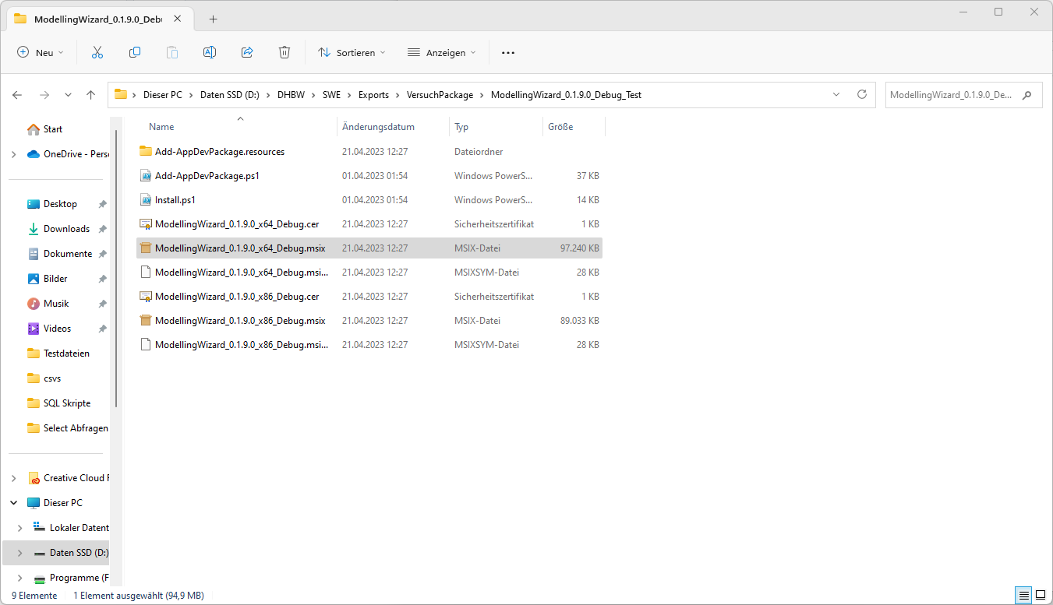

Choose Eigenschaften

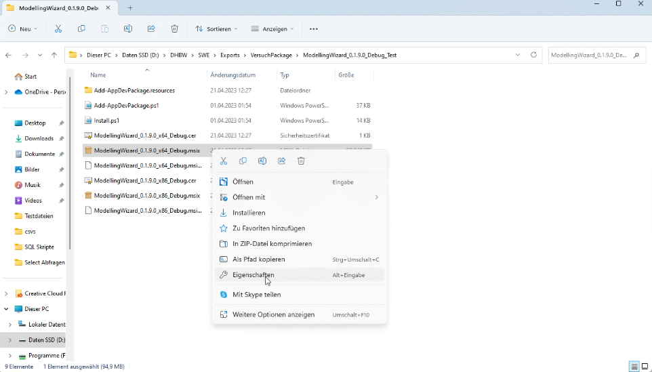

Choose Menupoint Digital Signature

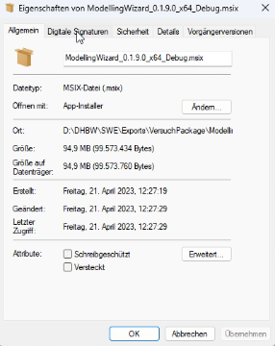

Choose the certificate of TINF21C

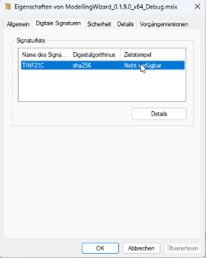

Click Details

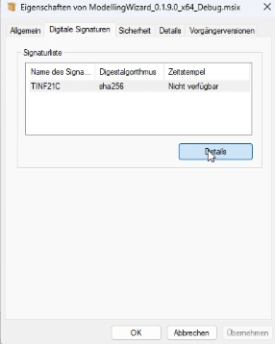

Click Zertifikat anzeigen

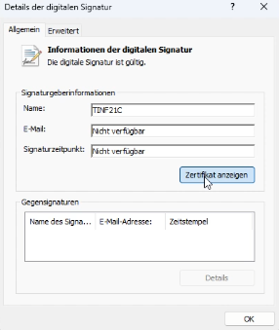

Click Zertifikat installieren

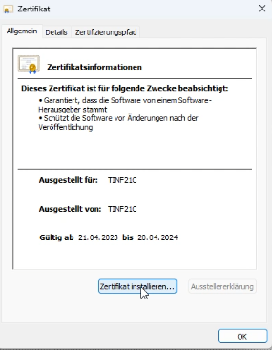

Choose the option "Lokaler Computer"

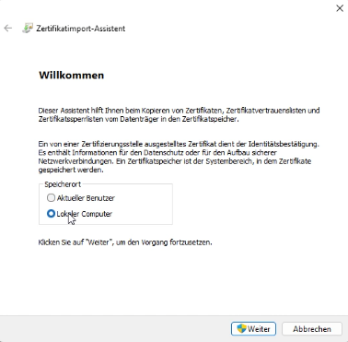

Choose "Alle Zertifikate in folgendem Ordner speichern" and Click "Durchsuchen"

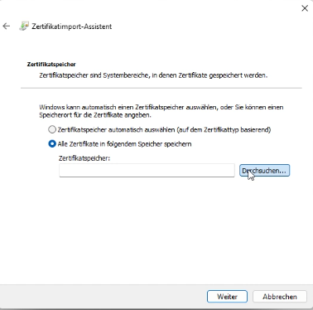

Choose "Vertrauenswürdige Personen"

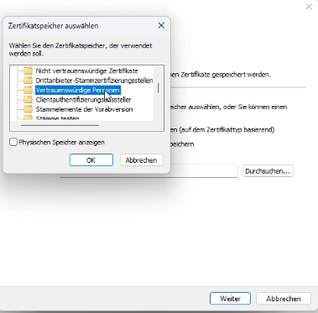

Click"Weiter"

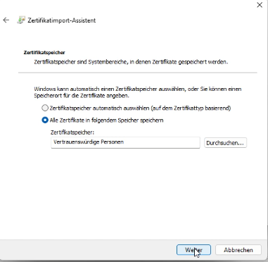

Click "Fertig stellen" to import the certificate.

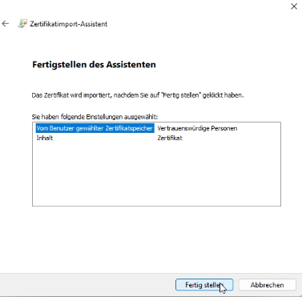

Try to open the MSIX file again. Now you should be able to install the modelling wizard.

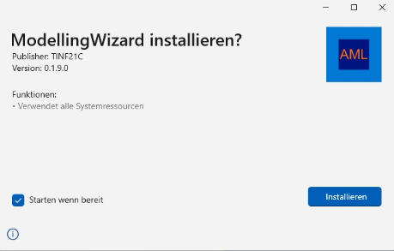

# Starting screen

Ein Bild, das Text, Screenshot enthält.

When you open the Modelling Wizard you should be confronted with this menu.

If you want to use an existing file to work on, please click on “Open File”.  
If you rather want to start from the beginning and create a new file, please click on “Create new File”.

If you click on “Open File”, a new Window should open where you can select the file you want to work on.  
If you click on “Create new File”, the standard Graphical User Interface will appear.

# Graphical User Interface

Ein Bild, das Text, Screenshot, Software, Multimedia-Software enthält.

## 4.1 General Information

The purpose of this chapter is to explain the user interface for Modelling Wizard. There are four tabs in the program that contain information. The functions of each tab and their options will be explained in its own subsection.

### 4.1.1 Selecting and adding a Library

Ein Bild, das Text, Screenshot, Software, Multimedia-Software enthält.
There is a button labeled "Libraries" in the header bar. Libraries serve as templates for adding individual classes. You can select one of the already loaded libraries or add a new one. To add a library, press the "Add Library" button. Now the file explorer opens, and you can load the desired library.

### 4.1.2 System Classes tab

This tab allows to view and edit the System Classes of the device.

On the left side there is a navigation view with the loaded System Unit Classes. For a new file, only the "AutomationComponent" class is displayed. Now you can select the desired class. After the selection, the attributes are displayed on the right side. If the object contains single components of attributes, they will be displayed collapsed. You can now expand the individual elements by clicking on the small arrow in front of the desired component name.

The individual attributes are displayed in a table and can now be edited. To do this, double-click on the value column of the desired attribute. Please note that Manufactorer and ProductCode are required data. These are therefore also highlighted in color. If one of these values is not filled in, the row will be highlighted in red. After a valid input, the color will change to green.

It is possible to add a new System Unit Class by pressing the Add button located at the bottom left. A dialog window will open. In the dialog window the currently available System Unit Classes are displayed, which are loaded from the used library. Now you can select an element or class from the displayed list. If you want to add only a single object, you have to open the top class of the desired object by clicking on the small arrow in front of the class name. If a class does not have this arrow, there are no other child objects of the class.

Also, it is possible to remove added system classes. To do this, move the mouse to the left navigation bar and right-click on the System Unit Class to be removed. Now a dialog window opens. Here you must confirm that you want to remove the desired class. If you do not want to remove the selected class, cancel the process with the "Cancel" button.

### 4.1.3 Role Classes tab

This tab allows to view and edit the Role Classes of the device.

On the left side there is a navigation view with the loaded Role Classes. For a new file, no class is displayed. It is possible to add a new Role Class by pressing the Add button located at the bottom left. A dialog window will open. In the dialog window the currently available Role Classes are displayed, which are loaded from the used library. Now you can select an element or class from the displayed list. If you want to add only a single object, you have to open the top class of the desired object by clicking on the small arrow in front of the class name. If a class does not have this arrow, there are no other child objects of the class.

Now you can select the desired class. After the selection, the attributes are displayed on the right side. If the object contains single components of attributes, they will be displayed collapsed. You can now expand the individual elements by clicking on the small arrow in front of the desired component name.

The individual attributes are displayed in a table and can now be edited. To do this, double-click on the value column of the desired attribute.

Also, it is possible to remove added role classes. To do this, move the mouse to the left navigation bar and right-click on the Role Class to be removed. Now a dialog window opens. Here you must confirm that you want to remove the desired class. If you do not want to remove the selected class, cancel the process with the "Cancel" button.

### 4.1.4 Interfaces tab

The Interface tab allows you to add Interfaces to the device. On the left side there is a navigation view with the loaded Interfaces. For a new file, no interface is displayed. It is possible to add a new Interface by pressing the Add button located at the bottom left. A dialog window will open. In the dialog window the currently available interfaces are displayed, which are loaded from the used library. Now you can select an element or class from the displayed list. If you want to add only a single object, you have to open the top class of the desired object by clicking on the small arrow in front of the class name. If a class does not have this arrow, there are no other child objects of the class.

Also, it is possible to remove added interfaces. To do this, move the mouse to the left navigation bar and right-click on the interface to be removed. Now a dialog window opens. Here you must confirm that you want to remove the desired interface. If you do not want to remove the selected interface, cancel the process with the "Cancel" button.

Ein Bild, das Text, Screenshot, Multimedia-Software, Software enthält.

### 4.1.5 Attachments tab

The Attachments tab offers the possibility to add attachments like pictures or PDFs to your device file. To do as such, simply click “Add attachments” and a file browser opens where you can select your file to attach. For supported file formats (currently only txt files) the content is displayed on the right side.

Also, it is possible to remove added attachments. To do this, move the mouse to the left navigation bar and right-click on the attachment to be removed. Now a dialog window opens. Here you must confirm that you want to remove the desired attachment. If you do not want to remove the selected attachment, cancel the process with the "Cancel" button.

Ein Bild, das Screenshot, Software, Multimedia-Software, Text enthält.

## File Import

Like previously mentioned, the Modeling Wizard program offers the capacity to import a file and show its properties. Kindly note that you are simply ready to open files that are saved in the AML (.aml; .amlx; .edz;) document type. To open an AML document, start the Modelling Wizard and select in the header bar "File" - > "Open". A file browser will open, where you can select the file.

Ein Bild, das Text, Screenshot, Software, Multimedia-Software enthält.

## File Export

To Export your data, select on the header bar “File” -> “Save”. A file browser will open, where you can choose a name and a location for the exported file. The default name will be the manufacturer and the product code of the first AutomationComponent in System Classes separated by a dot.

Ein Bild, das Text, Screenshot, Software, Multimedia-Software enthält.

## Change editing mode

In order to improve the usability and user friendliness the application was split into two separate modes. The "Easy" mode and the "Expert" mode. To switch between the modes, click the "option" button in the header bar. There you see the option "Expert mode" if you are in easy mode and "Easy mode" if you are in expert mode.

Ein Bild, das Text, Screenshot, Software, Multimedia-Software enthält.

When you are in expert mode, the attribute list in the right-center of the screen contains more information than in easy mode.

Ein Bild, das Screenshot, Text, Software, Multimedia-Software enthält.

## Dark- and Lightmode

To switch between dark- and lightmode, click the “Options” tab in the header bar and click on the Mode to switch to it. By the first run of the application the selected system theme from windows will be used.

Ein Bild, das Text, Screenshot, Software, Multimedia-Software enthält.

## Change CAEX Version

To switch the current CAEX version you can select it in the "Options" which you can find in the toolbar menu.

Ein Bild, das Text, Screenshot, Software, Multimedia-Software enthält.

The different versions are CAEX 3.0 and 2.15. If you are currently in CAEX 3.0 then you have the possibility to switch to 2.15 displayed in "Options" and vice versa.

# Copyright

The Modelling Wizard for Devices is a program that can be used to create or modify devices and interfaces. It can also be used to import IODD and GSDML, CAEX 2.15 and CAEX 3.0 files that will be converted to the AMLX (.aml; .amlx; .xml;) package.

Version 3.0.0

Design and Software development by

TINF17C DHBW Stuttgart

and Master Student Raj Kumar Pulaparthi, Otto-von-Guericke University Magdeburg

and TINF19C DHBW Stuttgart

and TINF20C DHBW Stuttgart

and TINF21C DHBW Stuttgart This programm was created as a group project in the "Software Engineering" class.

TERMS AND CONDITIONS FOR COPYING, DISTRIBUTION AND MODIFICATION

The General Public License (GNU)

Copyright © 2023 TINF21C DHBW Stuttgart

This program is free software: you can redistribute it and/or modify it under the terms of the GNU General Public License as published by the Free Software Foundation, either version 3 of the License, or (at your option) any later version.

This program is distributed in the hope that it will be useful, but WITHOUT ANY WARRANTY; without even the implied warranty of MERCHANTABILITY or FITNESS FOR A PARTICULAR PURPOSE. See the GNU General Public License for more details.

You should have received a copy of the GNU General Public License along with this program. If not, see https://www.gnu.org/licenses/.

© TINF21C DHBW Stuttgart 2023

This program uses third-party software for the conversions of IODD and GSDML. All rights are reserved by the corresponding copyright owner.